(Cover)
(Letter of Transmittal)
(Title Page)
(Executive Summary)
Table of Contents

List of Illustrations

Glossary

CSS : | Scripts that can overwrite styles of Hyper Text Markup Language (HTML) elements. They are used to position, size, fade, hover, hide, color, highlight, border, etc. many HTML elements.
Register:
ID / Key Values: | Unique numeric or alpha-numeric label assigned to specific data for database query and access.
Background

Meridian Project Systems

Meridian Project Systems is a software company that provides enterprise construction project management solutions with their three main products: Prolog, Proliance and ProjectTalk.

“Meridian Systems provides enterprise project management software for optimizing the plan, build and operate lifecycle for real estate, construction and other physical infrastructure initiatives. Building owners, construction and engineering firms, and government agencies use Meridian technology to improve top-line revenue growth while reducing their capital construction costs.”

Proliance, a relatively new product, offers project management through a webpage interface. That is, the software is web-server based and is accessible by web browsers to allow availability to users from virtually anywhere with internet connection once a server is deployed. The software has many divisions in terms of the user interface and front end. It separates levels of access, or “workspace”, into: organization, program, and project with increasing detailing and decreasing roles, authority, and coverage. Each user is given their own credentials, and depending on their account setup, they have different access or restrictions in these workspaces. Within each workspace, there exists several different types of documents. These documents are web-based forms and fields that varies between each document. Some of these document include contracts, cashflows, daily work journals, drawings, request for info’s (RFI), reports, summaries, resources, assets, work orders, etc. As there are many document types in each workspace, only a few examples are listed. Generally, Proliance bears a resemblance to current web-based email interface. Email webpages show a list of all emails subjects and senders within a folder as Proliance shows a list of all applicable documents in a register⊥ layout. These registers can be filtered, sorted, paged, or categorized to select particular documents. The back-end of Proliance is written in Visual Basic .NET output to the browser as ASP.NET.

Proliance
(Include an overview of Proliance)
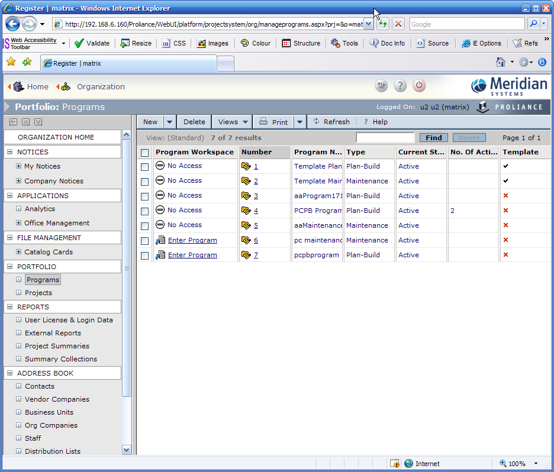

Section 508

Proliance is at a current (as of the end of 2006) release of version 3.6. Version 4.0 is dedicated to have a particular feature to comply with accessibility requirements under Section 508. The Section 508 law was enacted to require electronic and information technology accessibility of Federal agencies enabling more disabled users to access these technologies.

“In 1998, Congress amended the Rehabilitation Act to require Federal agencies to make their electronic and information technology accessible to people with disabilities. Inaccessible technology interferes with an individual's ability to obtain and use information quickly and easily. Section 508 was enacted to eliminate barriers in information technology, to make available new opportunities for people with disabilities, and to encourage development of technologies that will help achieve these goals. The law applies to all Federal agencies when they develop, procure, maintain, or use electronic and information technology. Under Section 508 (29 U.S.C. ‘ 794d), agencies must give disabled employees and members of the public access to information that is comparable to the access available to others. It is recommended that you review the laws and regulations listed below to further your understanding about Section 508 and how you can support implementation.”

The technical details of Section 508, however, cover a large area of requirements and thus this project is allocated as an ongoing project with implementations over multiple releases. In brief, 508 criteria for web development concerns visual readability, screenreader support, and ability to customize the page to suit the needs of users of low visual tolerance. But in the specifics of 508 criteria, these areas of concerns are broken down into several different technical sections for more discrete and narrow measurements of compliance. The 508 compliance standards for web-based products are listed under §1194.22 of Section 508 and are listed in Appendix I of this report. Proliance follows this §1194.22 subpart of Section 508 as it is a web-based software.

Introduction

Software development goals often differ between hobbyists, software development organizations, and corporate companies. The goals of software development within a development organization are generally efficiency, usability, and accessibility. All these goals will almost always merge into one ultimate objective: customer satisfaction. Accessibility plays a role of equal importance as efficiency and usability in customer satisfaction. As a software development company, Meridian Project Systems (MPS, Development) parallels with this generalized software development organization in its goal as the 2006 mission statement of MPS reads: “The Customer”. One particular feature for Meridian Project System’s relatively new web-server based project management product, Proliance, is in development to meet this requirement for accessibility. The development of this feature strictly follows the requirements under Section 508 (Appendix I). Version 3.5 of Proliance has had implementatations to comply with (a) and (b) under the §1194.22 subpart of Section 508 compliance. Version 3.6 aimed to implement (d), readability, into Proliance.

Readability requires that the web pages are organized such that contents are visually readable without applying Cascading Style Sheets (CSS). In addition, this section also requires that screenreaders⊥ are able to read back audibly a webpage in a logical and organized manner without extra or missed information. Many webpages use CSS to hide elements on a webpage. These include, images, dynamic elements that only appear with certain actions, and some form of programming ID’s or key values. As audited for 508 compliance, this readability section was not compliant and was planned to be implemented into version 3.6 before official work of version 3.6 began. The purpose of this report is to document the methodologies, expected and unexpected results from quality assurance of 508 readability compliance in Proliance 3.6.

Resources

The development of Meridian Project Systems is resourced in the Vancouver office and outsourced to another office in St. Petersburg.

Human Resources

The 508 project for Proliance 3.6 consists of 5 resources in Vancouver and the St. Petersburg (SPB) team. The project manager is Liana Aghasyan. There are two quality assurance resources allocated to 508 project: Alona Aldana, and Peter Chen. Other resources within the team are software development programmers.

Hardware and Software Resources

The hardware and software resources for the testing of 508 readability is listed in the following table (Table 1)

Table 1: Hardware and software resource table.
Resource Item | Resource Details | Cost
Workstation | Microsoft® Windows XP SP2  Intel® Pentium 4
Browser | Microsoft® Internet Explorer 6 / Microsoft® Internet Explorer 7
Browser add-ons | Vision Australia Web Accessibility Tool Bar  Microsoft® IE DevToolBar
Main Test Server | The main test server is hosted over a server load-balanced system over two server machines with a DNS name for access.
508 Test Server | The 508 specific test server is hosted over a single machine without a DNS and is only accessible through machine IP.
Screenreader | Demonstration version of JAWS 7.0 (Job Access With Speech) by Freedom Scientific. The demonstration version was initially used when a license was still in purchase. The demo license expires in 40 minutes and requires a reboot to reuse.  Licensed version of JAWS 8.0 Professional. | ~ $1000 USD.

Methods
The testing scope of Proliance readability was separated into two groups: registers and document. Prior to 508 teadability testing of Proliance 3.6, there were already a few known 508 related defects reported by Criterion 508⊥ in the audit document. These are various form controls hidden by CSS used with GUID (Global Unique ID) and other identifier values to perform actions on documents. Due to the severity of these known issues that occured in the document pages, register pages were tested before document pages.

Scenarios

There are two general scenarios in testing the webpages for readability: disabling CSS and employing screenreaders.

Disabling Cascading Style Sheets

Disabling stylesheets is achieved by using either the Internet Explorer Development Toolbar (DevToolbar) by Microsoft® or AIS Web Accessibility Toolbar by Vision Australia. These internet explorer toolbars have the option to disable stylesheets of any webpage. Disabling stylesheets usually places html elements in a linear fashion. This helps to determine whether contents of a webpage logically flow in order.
(diagram)
Also, stylesheets with particular definitions such as when “none” is defined for the display attribute, the element with that CSS definition is visually hidden. When CSS is disabled, this element is revealed on the plain HTML page. Disabling CSS helps to identify when elements as such are hidden for aesthetics, or security purposes that is problematic when accessed by users who shouldn’t be able to access them. In addition, stylesheets are commonly used to alter the size of division, span, table, or image elements. When CSS is disabled, these stylesheet settings are ignored and their dimensions are reverted to standard HTML default settings. This is an issue when the original HTML settings are improperly sized. This testing resulted in several recursive issues in Proliance and is discussed in the Discussion section of this report.

Screenreading

CSS defines the layout of a webpage. Not only do stylesheet-hidden elements pose a problem when CSS is disabled, it also creates confusion for screenreader users. Not all screenreading software are able to understand stylesheet scripts and cannot parse them when reading back to visually impaired users. Screenreaders perform, not only to read back the visuals, but also they allow blind users to navigate and perform actions using the keyboard. When elements are hidden, it may still be read back by some screenreaders and can be accessed by users. Screenreading testing involves listening to JAWS for playback on the webpages. If any extranneous information is read back but is not visible on UI, they are noted as defect.

Register Page Testing

Registers document pages testing was separated into 16 different groups of coverage. These are:
  - Workspace Home Pages
  - Organization Document Registers
  - Organization Non-Document Registers
  - Organization Wizards
  - Organization Document Tabs
  - Plan-Buid Project Document Registers
  - Plan Build Program Document Registers
  - Maintenance Program Registers
  - Maintenance Project Registers
  - Plan-Build Project Wizards
  - Plan-Build Program Lookup⊥ Version Manager / Lookup Manager Tabs
  - Register Report Elements
  - Register Elements
  - Picklist Elements
  - Lookup Version Manager Elements
  - UI Tailoring⊥

The method of testing of each of the groups listed above is achieved by following through scenarios documented on internal document test plans.

Table 2: “Scenario 1 [TC1340]: 508 Compliance Readability on document / non-document Registers, selected document tabs, picklists” Table extracted from D3565. (2006, A. Aldana)
Step | Step Type | Description | Notes | Req ID
1 | Setup | Log in to a workspace, as user with administrator access, and go to Equivalence Class (EC) 1 .
2 | Setup | Turn off associated CSS.
3 | VP⊥ | Verify that contents are readable, and with logical flow. |  | 508 Section 1194.22
4 | VP | Verify that there are no superfluous contents (ex. document GUIDs), or hidden non-text element associated with CSS. |  | 508 Section 1194.22
5 | VP | Where applicable, verify the results based on EC 12 (Register Report elements).
6 | VP | Where applicable, verify the results based on EC 13 (Register elements).
7 | VP | Where applicable, verify the results based on EC 14 (Picklist elements).
8 | VP | Where applicable, verify the results based on EC 15 (Lookup Editor elements).
9 | VP | Where applicable, verify that applied custom cultures are visible on register and picklists UI.
10 | VP | Where applicable, verify that the ‘Date Format’, and ‘No. of List Items’ changes made to ‘My Preferences’ are correctly displayed in the registers.
11 | Setup | Perform steps 2 to 10 for EC 2 to EC 11
12 | Setup | Without turning off associated CSS, and using a screen reader go to EC 1 to 11
13 | VP | Verify that screen reader can read the page, and user is assisted to navigate thru the page to perform his tasks.
14 | Setup | Log in to a workspace, as user using EC 16 (UI Tailoring)
15 | Setup | Turn off associated CSS.
16 | VP | Verify results based on EC 16 (UI Tailoring)
16 | Setup | Without turning off associated CSS, and use a screen reader to read thru the register page.
17 | VP | Verify that screen reader can read the page, and user is assisted to navigate thru the page to perform his tasks. The affected register buttons should not be available for screen reader to read.

Document Page Testing

There are numerous types of documents in Proliance. Testing every type of document is impractical and too time consuming especially with a screenreader. But since the programming behind the document pages rely on a single platform to render different document pages, many documents share the same properties. This also implies that a single fix for a defect on one particular document can cover many documents with the same defect. Because of this, only a few documents were selected from each similar set of documents. The resulting numbers of document to test were significantly reduced to approximately 70 documents. Though there are a lot of similar documents within the 70 documents assigned to be tested, the difference between the similar documents were different levels of workspace. Different workspace provides different access for the documents and are thus not omitted in the selection of testing coverage.

Document page testing was separated into seven groups of coverage.
These are:
  - Organization Workspace (9 document types)
  - Plan-Build Program Workspace ((9 document types)
  - Plan-Build Project Workspace (13 document types)
  - Maintenance Program Workspace (11 document types)
  - Maintenance Project Workspace (7 document types)
  - Organization Wizards (5 document types)
  - Project Wizards (14 document types)

Discussion

The requirement for 508 readability, as stated by Criterion 508, is to ensure that webpages are readable, by visual reading or screenreaders, without the need to apply external stylesheets. Users of Proliance in this case are assumed to be either of low visual tolerance, or completely visually disabled. Users of low visual tolerance may be able to read the screen to a certain level. They, however, also may require disabling of stylesheets in order to apply their own styles to webpages (e.g bigger text size, no images, etc.).
Web Accessibility Toolbar (refered to as WAT) has a better implementation as it turns off CSS at the browser level whereas DevToolbar only disables on the Document Object Model (DOM) level of webpages.
display: none;

Results

As previously stated, the audit document provided by Criterion 508 initially reported a few issues with readability compliance to expect when testing began.

Expected Results

The anticipated issues given by Criterion 508 are concerned with superfluous information hidden by stylesheets in register tables. Many GUID were displayed in the register tables when CSS is disabled. These are used for data querying from databases. Figures A and A1 show an example of this defect.


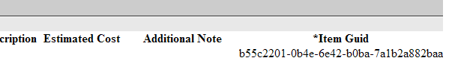

Additionally, many non-text elements are hidden due to design changes but were not removed by script. For example, in Figure B and B1, there was a My Desktop image with accompanying text used in the workspace selection home page. Screenreaders are able to identify this image and the text.

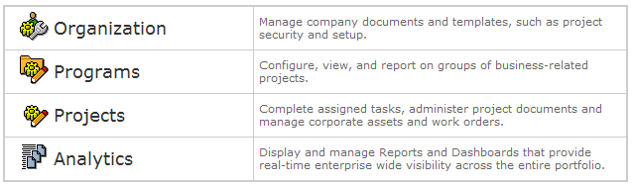

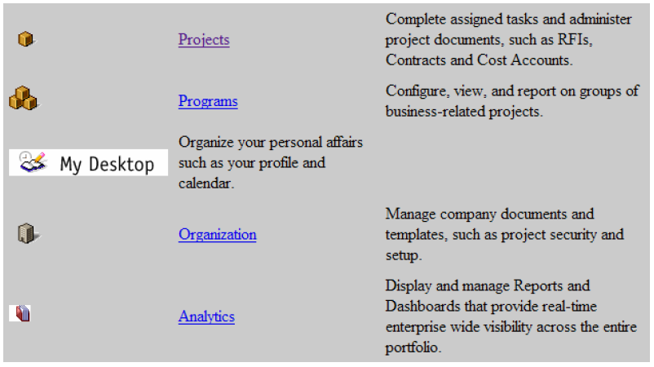

Unexpected Results

The issues that Criterion 508 addressed were implemented into version 3.6 and the testing was aimed to catch any similar bugs that were not included in the fix. These, however, were not the only issues impeding 508 compliance of Proliance. There were many severe issues determined by the developer and programmers, and there were many issues detected during testing by quality assurance.

The issues raised by the developers are listed below:

- Hidden calendar control
  - Many documents have input fields for users to input date in MM/DD/YYYY format by default. There is also a button beside these fields that opens up a popup of a calendar interface in which users are able to select a date instead of having to type out the date in the input box. These popup controls are hidden by CSS and thus are unhidden when CSS is disabled displaying at the top of the documents as shown in Figure C.
  - 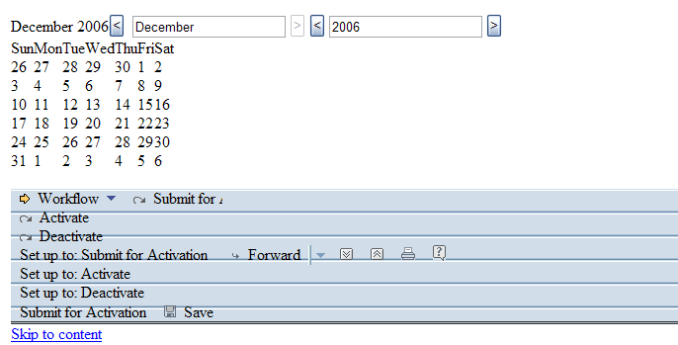
  - Hidden textbox/form controls
  - Unusable Expand Collapse definitions

Missed Alt Text for Images
Wizards
Scrollbars
  - Broken Image Links
  - HTML/CSS definitions
  - Dynamic page viewing (filters)
  - Overlapping Text
  - Old UI interface hidden
  - Radio/checkbox/textbox editable/non-editable
  - Link Errors
  - Javascript Errors
  - Visual difficulty
  - Conclusion

References
Appendix 1

§ 1194.22 Web-based intranet and internet information and applications.

(a) A text equivalent for every non-text element shall be provided (e.g., via "alt", "longdesc", or in element content).
(b) Equivalent alternatives for any multimedia presentation shall be synchronized with the presentation.
(c) Web pages shall be designed so that all information conveyed with color is also available without color, for example from context or markup.
(d) Documents shall be organized so they are readable without requiring an associated style sheet.
(e) Redundant text links shalkl be provided for each active region of a server-side image map.
(f) Client-side image maps shall be provided instead of server-side image maps except where the regions cannot be defined with an available geometric shape.
(g) Row and column headers shall be identified for data tables.
(h) Markup shall be used to associate data cells and header cells for data tables that have two or more logical levels of row or column headers.
(i) Frames shall be titled with text that facilitates frame identification and navigation.
(j) Pages shall be designed to avoid causing the screen to flicker with a frequency greater than 2 Hz and lower than 55 Hz.
(k) A text-only page, with equivalent information or functionality, shall be provided to make a web site comply with the provisions of this part, when compliance cannot be accomplished in any other way. The content of the text-only page shall be updated whenever the primary page changes.
(l) When pages utilize scripting languages to display content, or to create interface elements, the information provided by the script shall be identified with functional text that can be read by assistive technology.
(m) When a web page requires that an applet, plug-in or other application be present on the client system to interpret page content, the page must provide a link to a plug-in or applet that complies with §1194.21(a) through (l).
(n) When electronic forms are designed to be completed on-line, the form shall allow people using assistive technology to access the information, field elements, and functionality required for completion and submission of the form, including all directions and cues.
(o) A method shall be provided that permits users to skip repetitive navigation links.
(p) When a timed response is required, the user shall be alerted and given sufficient time to indicate more time is required.
Questions.

Privacy Issue – Names?
Images

example of document page
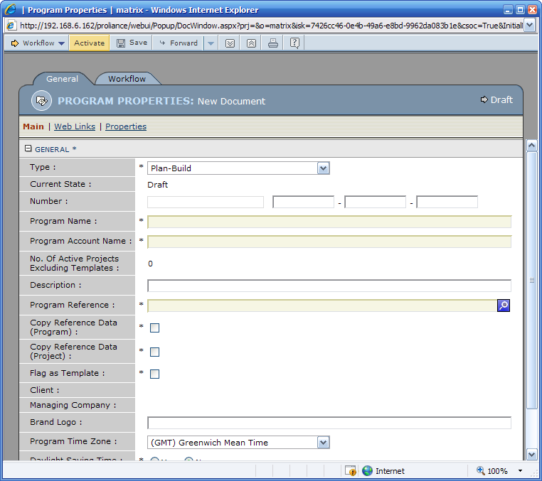

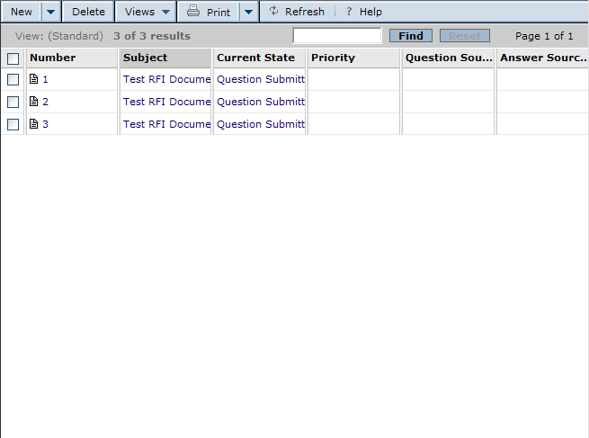

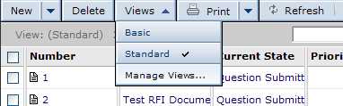

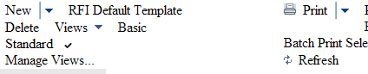

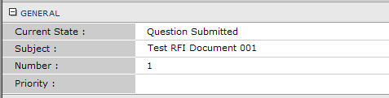
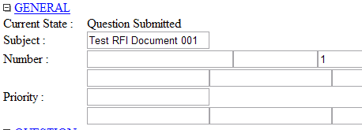
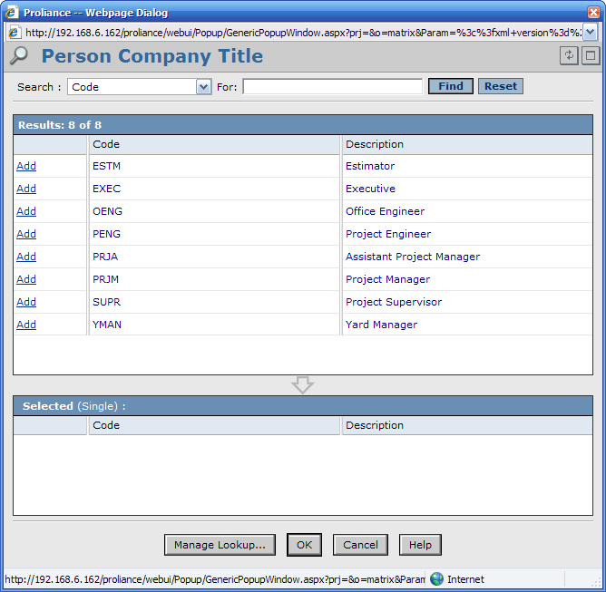

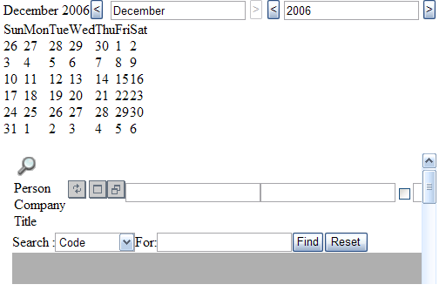

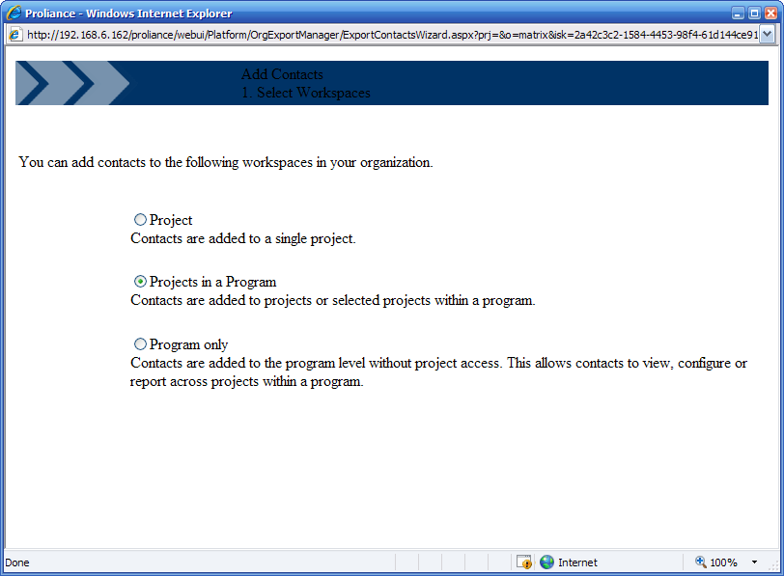
Here is the list of controls that have been changed in 3.6. They will need some regression testing to ensure that nothing is broken. If you still cannot locate the controls, let me know and I will find more details.

- Document Section Menu (it is the menu on the document page for changing sections – it used to have a hidden texbox before)
- Document Reference fields
- Lookup fields
- Currency Type fields (Project Properties Page on Project Side)
- VisualID fields
- Document Reference List controls (see in Attachments tab of each document / Attached Documents)
- Document Type controls (in Hold document / Filtered Documents / Document Types to hold)
- URLLinkFieldRow (in External Reports document)
- DataTableControl (Staff Document, User Account Section, Principal Row)
- ItemListFieldControl (any itemlist, e.g. AREAS on RFI)
- AddressListFieldControl (Staff/Contact Addresses itemlist)
- LayoutFieldControl (CPL document, layout picker)
- PeriodFieldControl (RevenuePaymentLog General tab)
- ToggleImage (is not currently used)
- WindowSizeButton (lookup picker)
- EmailTextBox (Staff/Contact document)

Thanks,
Liana

Hello Liana,
Almost all standard controls are fixed, except the MultiTypeFieldControl.
With textboxes:
- Document Section Menu,
- Document Reference fields,
- Lookup fields,
- Currency Type fields,
- VisualID fields,
- Document Reference List controls (see in Attachments tab of each document / Attached Documents),
- Document Type controls (in Hold document / Filtered Documents / Document Types to hold),
- URLLinkFieldRow (in External Reports document).
- DataTableControl;
- ItemListFieldControl / AddressListFieldControl;
- EmailTextBox;
- LayoutFieldControl;
- PeriodFieldControl;
- WindowSizeButton (to resize dialogs).
Fixing controls (checkboxes, radiobuttons, lists, comboboxes) that we hide using style sheet definition:
- EnumDropDownList,
- ItemListFieldControl (here the row selector checkbox is not rendered anymore in read-only mode),
- BooleanFieldControl,
- EnumDropDownList,
- EnumRadioButtonList,
- HourTimeDropDownList,
- LookupItemExFieldRow,
- SingleSelectBox.
In non-editable mode their state is stored/restored in ViewState.
All changes will be valid from version 3.60.0077.
Regards,
Ivan Kanivets

Hello Liana,
Here is the additional list of controls with textboxes that must be hidden, I fixed them today, see CL#44405:
- DataTableControl
- ItemListFieldControl / AddressListFieldControl
- LayoutFieldControl
- PeriodFieldControl
- ToggleImage (is not currently used)
- WindowSizeButton
- EmailTextBox
The list of controls with checkboxes / radiobuttons / comboboxes / list that are visible (in edit mode, in most cases) or hidden (in view mode):
- ItemListFieldControl / AddressListFieldControl
- BooleanFieldControl
- EnumDropDownList
- EnumRadioButtonList
- HourTimeDropDownList
- ItemDropDownList
- LookupExListBox
- SingleSelectBox
There are two solutions at least:
- skip this HTML controls rendering in case of View mode, and render only text labels. It is possible that these HTML controls are used in some JavaScripts, but I assume that in View mode there are no such JavaScript processing active. But in this case the control state is lost on page postback and when we go from view to edit mode. It is necessary to rewrite BaseDocumentPage class to re-initialize controls in this case.
- put a value in hidden input field in View mode, and rewrite each control to get/put control's value either from original checkbox / radiobutton / combobox / list control, or from this hidden input depends on view/edit mode (and on previous view mode state).
Special case:
- MultiTypeFieldControl
Here a number of controls for different types of data are placed on HTML page, but only one is visible depends on datatype. Visibility can be changed dynamically on client side. I will look more deeply what can be done here.
Moreover, ANY document field control, if it is marked as IsNotVisibleOnUI in document template, will be rendered with display:none style. This was done to avoid problems in JavaScript when there is a reference to a particular control.
Regards,
Ivan Kanivets

Hello Alex,

We found more Readability issues in Proliance and some of them might have a high impact and we might decide not to include them in 3.6 project. Could you please review all these items and provide estimates / assess impact of the changes and maybe propose solutions? I have done some investigation, but I wanted to get your opinion as well. Depending on that, we will decide whether we want to include these changes as part of 3.6 or 4.0 project. All issues are reproducible when style sheets are disabled.

- Sidebar menu on registers: catalog card template menu items contain template guids when you turn off the style sheets. To be able to reproduce this, you will need to create multiple templates for catalog cards.
- Document Reference Fields: we have at least 3 textboxes that we hide using style sheet definition. I contacted the audit company to find out if we can use some sort of attributes to mark these as system textboxes, but I haven’t heard anything back from them.
- Lookup fields: the same as reference fields
- Currency fields: the same as reference fields
- Calendar Control: I am not sure why anymore, but for some reason we have calendar control defined on every single document page(only in Edit mode). I hope we can use html attribute here as well, but if not, is there a low impact solution that would help us to not have this control defined on the page?
- Document Section Menu: it displays a hidden text box.
- Register Toolbar: the buttons are not logically organized. Alona even logged an issue on this(https://portal.mps.com/pivotal/issue.aspx?Number=53368 ). This probably can be deferred to Scripts section. I personally cannot think of any good solution right now.
- Document Page Toolbar: again, if you turn off style sheets, the buttons are all over the places. If we can any way organize the buttons better without big changes (at least make them appear as in registers), it would probably work. Some of it, again, can be deferred to Scripts.

Web Grid related (I don’t think we can do much about it, just wanted to communicate this to you):

- Expand/Collapse buttons don’t work if style sheets are turned off: we will probably have to communicate this with USPS on this issue.
- Edit Cell appears at the top of the page: I talked to Chris, as far as I understand, this is by their design
- All custom editors are hidden using style sheets: nothing we can do about this other than communicating it with USPS.

Since some of the changes might be part of 3.6 project, this takes higher priority than any other Northstar work. Could you please spend some time investigating these issues. If you cannot find any solution, we just need to communicate to USPS and Jeff. Please don’t check in any changes, we would like to assess the impact first.

Thanks,
Liana

 Register: (blah). All text marked with this symbol are defined in the glossary from this page on.
 Recursive general technical terminology not strictly associated with Proliance are defined in the glossary and will be marked with this symbol  from this page on.
 Screenreaders: Software capable of identifying elements in softwares or webpages and reading back elements audibly to aid visually impaired users.
 Criterion 508: An auditing company providing service to inspect and review 508 compliance.
 Lookup:
 UI Tailoring:
 VP: Validation/Verification Process

