Design, Experimentation, and Simulation of Small Angle X-Ray Scattering
APSC 310 Report
Presented by
Tso (Peter) Chen

to

Konstantine Kaznatcheev
&
Chithra Karunakaran

[Canadian Light Source Inc.]

Student #: 16205031
August 13, 2007

UBC Engineering Physics, Science Co-op
University of British Columbia

Letter of Transmittal

Tso (Peter) Chen
UBC Science Co-op Program
Chemistry/Physics 170
6221 University Blvd
Vancouver BC, V6T 1Z1

August 31st, 2007

Chithra Karunakaran & Konstantine Kaznatcheev, Staff Scientists
Canadian Light Source Inc.
101 Perimeter Road
Saskatoon, SK S7N 0X4

Dear Konstantine and Chithra:

I am writing to you with the project report titled the Design, Experimentation, and Simulation of Small Angle X-Ray Scattering enclosed. The purpose of writing this report is to document the analysis of the project in detail with respect to software design, mechanical construction, data acquisition and analysis, as well as some simulation of SAXS work done with you at the Canadian Light Source. This report is also written as a partial requirement for UBC Science Co-op credit. This is submitted as a final copy of the report. Please let me know if you have any concerns.

Sincerely,

Peter Chen

Enclosed: Project Report

Design, Experimentation, and Simulation of Small Angle X-Ray Scattering
APSC 310 Report
Presented by
Tso (Peter) Chen

Adressed to

Konstantine Kaznatcheev
&
Chithra Karunakaran

[Canadian Light Source Inc.]

Student #: 16205031
August 13, 2007

UBC Engineering Physics, Science Co-op
University of British Columbia

Summary
The Canadian Light Source is a 3rd generation synchrotron.

Abstract
The primary objective of most forms of microscopy today is to increase the optical spatial resolution. As spatial resolution is limited by the limited zone-plate focal diameter, a new X-Ray technique is required in order to achieve sub-50 nm resolution at the Canadian Light Source. Small Angle X-Ray Scattering seeks to answer the problem. The underlying technique exploited by SAXS is to capture the pattern formed by the elastically scattered photons from the electrons of the sample. The amplitude of the scattering is by definition the Fourier Transform of the electron density distribution of a defined a sample. Although possible, the reconstruction of the Fourier image back into the spatial dimensions is not the goal of this project. The primary goal of this project is to understand how the scattered pattern is affected by imposing different variables: geometry, nature of sample, energy, etc. The setup for this experiment required a CCD with PC communication and hence software was designed with a pre-purchased CCD. Software code was written in Microsoft® Visual Basic .Net 2003 through a development kit provided by the manufacturer of the camera. A few data sets were taken with variables of focus, consistency, energy, and sample. However, the camera broke down during the experimentation and camera repair was decided to be an uneconomic option. In order to understand Small Angle X-ray Scattering clearly without experimentation, a software simulation was needed. A few simple simulations were developed according to the spherical particle scattering model using GNUPlot. Though not enough data was obtained to provide a full analysis of SAXS before camera failure, a few conclusions can be made to the few variables that were tested. These include the change in pattern by defocusing and varying incident beam energy which is primarily the frequency differences in the interference patterns.
Table of Contents

Abstract I

List of Illustrations III

1.0 Introduction 1
1.1 Background 1
1.1.1 X-ray 2
1.1.2 TXM and STXM 2
1.1.3 X-ray Scattering 4

2.0 Equipments, Software design and Setup 7
2.1 Equipment 7
2.2 Samples 8
2.3 Charge-Coupled Device 8
2.4 Software Development 9
2.4.1 Data Processing 10
2.4.2 Binning, Shift Speed, Image Area, Exposure 12
2.4.3 Long Averaged Exposure 13
2.4.4 Beamline Parameters Control 13
2.4.5 AXis-readable File Export 14

3.0 Experimental Setup 15
3.1 External Setup of CCD 15
3.2 Internal Setup of CCD 16
3.2.1 Beam Stop 17

4.0 Discussion 18
4.1 External Setup Data Acquisitions 18
4.1.1 Data 18
4.1.2 Analysis 18
4.2 Internal Setup Data Acquisitions 21
4.2.1 Data 21
4.2.2 Analysis 21
4.3 SAXS Simulation 21
4.3.1 Debye's Formula – Spherical Particle Simulation 21
4.3.2 Single Particle Scattering Simulation 24
4.3.3 Paired Particles Scattering Simulation 25

5.0 Conclusion 27
6.0 References 28
7.0 Bibliography 29
8.0 Appendix 30

List of Illustrations
Figure 1 : Ray optics of TXM. The imaging technique can be represented by a "shadow" the different transmission detected determine the information of the sample.

Figure 3 : Simple 5-particle scattering system geometry.

Figure 4: (a) Each row of elements is shifted down. (b) The bottom row enters the shift register and is shifted out horizontally one pixel at a time. (Pixel dimensions are not actual dimensions)

Figure 5 : General flowchart of VB.NET algorithm used to process data

Figure 6: (a) Image taken by the developed CCD software through an adjustable objective lens with low exposure. Streaking effects are apparent. (b) The second image has higher exposure time (0.5 secs). The objects in view are gloved-hand, a bellow, and used aluminum sheets.

Figure 7: Binning is the hardware camera summing of pixel count values horizontally or vertically rather than software addition. This creates combined pixels called "Superpixels".

Figure 8 : Internal setup of the CCD and the PMT used for SAXS data acquisition. The PMT is held by a clamp attached to the arm of a linear stage. Note: except for the y-linear stage the PMT is attached to, both the CCD and the PMT share the same motion of x and z directional motion.

Figure 9 : PMT fine tip (approx 2.65 mm) blocking the 1st order beam divergent from the sample (bottom center hole of the 6 holes).

Figure 10 : Test mesh pattern of silicon wafer used as initial sample. This image is constructed from the STXM method.

Figure 11: Ray geometry showing that the CCD detector is placed too far from the sample in order to detect any scattered waves or speckles.

Figure 12 : Single particle simulation with arbitrary electron density and unit radius. A faint ring is seen around the central maximum, the ring shows the second maximum from the sinc function.

Figure 13 : Mathematica output of the intensity function defined by Rayleigh.

Figure 14 : Double particle scattering simulation data. The two particles are placed adjacent to each other horizontally. This likely is not the correct simulation.

Figure 15 : Simulation showing fault. With collimated propagating beams, the intereference pattern should show identical intereference between this and the interference above in

Table 1 : PCI Controller Analog to Digital Conversion

Introduction

Small angle x-ray scattering (SAXS) type imaging is an analytical imaging technique making use of the scattered photons from the interaction of x-ray and matter. These coherent (elastic) scattering interfere with each other producing diffraction or interference patterns. The patterns are then detected by film allowing the structural information of the sample matter to be derived analytically from the image of the pattern.

The Soft X-ray Spectromicroscopy (SM) beamline at the Canadian Light Source (CLS) currently employs the Scanning Transmission X-ray Microscopy (STXM) technique to image micron-scaled samples. The sample size limitation of this microscope demands a new imaging technique and thus the SAXS experiments are intended to serve as proof of principle in possible future implementation to the beamline.

With a pre-purchased charge coupled device (CCD) camera, communication software is developed as well as external supports were designed to allow proper acquisition of x-ray scattering data. This document will outline briefly the software development and mechanical designs where the focus of discussion is placed in small angle x-ray scattering experiments.

Background
Small angle x-ray scattering is a very large topic in discussion. This report aims to only discuss the relevant theory and physics used in the scope of the project. The current imaging technique, and small angle x-ray scattering are introduced in this section.

X-ray

First produced by Wilhelm Conrad Röntgen, x-rays are high energy electromagnetic waves with 10⁻⁸ m to 10⁻¹² m wavelength range. Hard (higher energy) x-rays are often used in medical imaging. X-rays penetrate matter more efficiently than visible light and are, therefore, used to image structure interiors by studying the amount of transmission. (Suhonen n.d.) The current technique used in the soft x-ray spectromicroscopy beamline at the CLS is the scanning transmission x-ray microscopy.

TXM and STXM

Transmission X-ray Microscopy (TXM), a technique used by some synchrotrons such as BESSY, uses the same basis of imaging as STXM; the absorptive property of x-ray energy by matter. As X-ray penetrates matter, a fraction of the energy is lost in the beam due to absorption of energy from electrons. TXM uses the divergent beam from a zone plate focused light source to cast a “shadow” on to a detector as shown in figure below. The zone plate is a circular lens-like piece with grooved surface like that of a diffraction grating. It acts as a lens for x-ray beams. The phase space, source size, and beam angle can be relatively large in this technique.
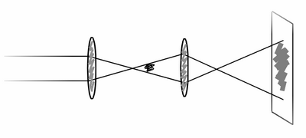
Zone Plate
Zone Plate
Sample
CCD
Figure 1 : Ray optics of TXM. The imaging technique can be represented by a "shadow" the different transmission detected determine the information of the sample.

STXM uses absorption of finely focused x-ray by matter to image small-scale samples. The x-ray beam is first focused by a zone plate to a focal diameter of approximately 50 nm. Like a diffraction grating, the zone plate produces different colors and orders of focused beam. Since only the 1st order is used, an order sorting aperture (OSA) blocks all other beams except for the 1st order beam. The sample is placed directly at the focal point of the beam and is translated in both X and Y direction by linear stages. This “scanning” will produce different transmission amount as the beam diverges away from the sample. This beam is then detected by a photomultiplier tube. With proper software, this information is pieced together and rearranged to display a scanned image.

[Figure of STXM]

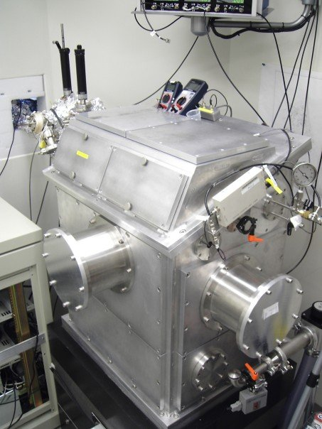
Figure 2: Vacuum sealed scanning Transmission X-ray Microscope. Top and front side covers allow accessing of components inside the chamber.
The STXM is a vacuum sealed chamber.

X-ray Scattering

Small angle x-ray scattering originated from crystal x-ray diffraction analysis (Guinier and Fournet 1955). The branch of small angle x-ray scattering primarily deals with non periodic (non-crystalline) matter. The limitation of the STXM is imposed by the inability to manufacture zone plates of less than 25 nm diameter focus. The smallest focus available at the CLS is approximately 50 nm. When the sample size is as small as 50 nm (or smaller), STXM is ineffective because 50 nm is the focal diameter of the x-ray beam. This 50 nm can be represented by one pixel in imaging. Therefore, scanning at nm scale would require a different imaging technique. SAXS aims to resolve this size constraint issue. When electrons are exposed to x-rays, the electrons absorb the beam and emit photons in different directions creating spherical scattering waves. Elastic scattering occurs when the emitted photon and the absorbed photon have the same energy (or wavelength). Secondary scattering also occurs from emitted photons but are weak. These scattered waves interfere with one another forming an interference pattern on a film detector. These interference patterns are also referred to as “speckles”. This is very much similar to Young’s double slit experiment but with a spatial 2D dimension.
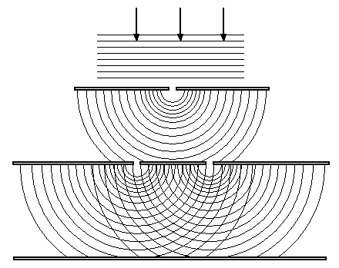
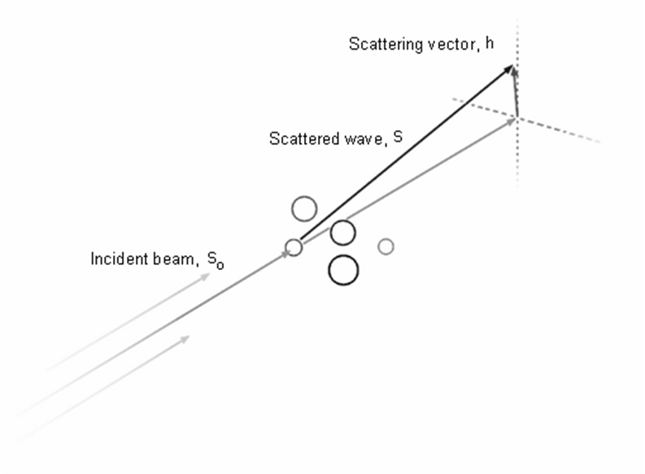
Figure 3 : Simple 5-particle scattering system geometry.

Scattering angle changes with the size of the scattering particle in focus. The scattering vector is defined as the vector in the direction of scattered beam, , subtracted by the incident beam,. This equation is defined by:

The magnitude of this vector is (Guinier and Fournet 1955):

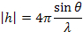

Equipments, Software design and Setup

Equipment

Andor DX-412 Back Illuminated CCD Camera (Vacuum supported)
Model: DX412-BN

CCD Detector Chip
Model: CCD77-00
512 x 512 pixel dimensions
12.3 mm x 12.3 mm detection area

PCI Controller Card
Model: CCI-010
A/D Resolution: 16-bit

Table 1 : PCI Controller Analog to Digital Conversion
Analog to Digital Rate | Digitization Time (μs) | Count Rate conversion  (electrons per count)
1 MHz | 1 | 7
500 KHz | 2 | 7
62 KHz | 16 | 5
31 KH | 32 | 2.5

Dell Windows XP SP2 Workstation
Pentium® 4 CPU 3.00 GHz
2.99 GHz, 2.00 GB of RAM

Note: Detailed datasheets of the CCD and the PCI card is attached in the Appendix.

Samples
Silicon Wafer Test Mesh Pattern

Ferrotec Corp. Ferrofluid – Iron Particles
Percentage Composition (by Volume):
1 - 4% Magnetite
7 - 27% Water Soluble Dispersant
69 - 92% Water
(Other details are listed in the Appendix)

Charge-Coupled Device

CCD's operate differently according to the user needs. The detection and output method of the DX-412 CCD is briefly described here in order to understand the purpose of binning, shift speed and exposure feature implementations in the software.

A charge coupled device is an integrated chip that converts the number of photons detected into electrons. The electron number is then counted into a count signal. The data output mechanism in the specific camera used is through a single shift register row as shown in figure below. Signals in the camera electronics trigger the start of electron count accumulation. When accumulation is finished, the image data is shifted vertically down by one row.

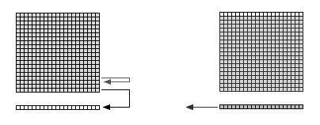
(a) (b)
Figure 4: (a) Each row of elements is shifted down. (b) The bottom row enters the shift register and is shifted out horizontally one pixel at a time. (Pixel dimensions are not actual dimensions)

The bottom row enters the shift register. This register is shifted horizontally to the left one pixel at a time until all pixels have exited the shift register. The image from the detection surface is then shifted down again where the next bottom row enters the shift register. This process is repeated until all data have been sent to the electronics and to the PC via the PCI card. This method is a little slower than alternative retrieval methods. Some CCD's are equipped with a secondary masked detection area. Instead of shifting one row at a time, all rows are shifted once into the masked pixels and are shifted out horizontally one column at a time.

Software Development

The software was written in Visual Basic .NET 2003. The software development kit was provided by the manufacturer (Andor) which is supported for Visual Basic 6. Adapted code for Visual Basic .NET 2003 was written by a previous student Jacob Stewart-Ornstein. Basic hardware-supported features implemented include: data to bitmap processing, binning, shift speed setting, image area selection, and exposure. The software extended features that were implemented are long exposures, beamline parameter read and control, and aXis-compatiable data file export.

Data Processing

Each data frame is received by the PC as an array of 16-bit integers. Converting these integers into a visible image required user defined functions to convert to proper RGB values. The array length depends on the dimension of the picture taken. The 512 pixel x 512 pixel picture will have a length of (512 x 512 = ) 262144. These integers are converted to counts by analog-to-digital conversion rate depending on the horizontal shift speed. The generation of the image uses a maximum and minimum algorithm to determine the proper brightness of each pixel such as the equation below.

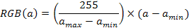

The array of data is looped through once to determine the maximum and the minimum value as shown in Figure 5. A secondary loop is used to parse each element in the array in order to normalize the raw data array into 8-bit integers. The flowchart below describes the data processing technique. RGB value is a set of three 8-bit (0 ~ 255) numbers. Since color is not differentiated from the camera, all three red, green, and blue values should be identical. The result of this is a grayscale image like the figure below.

Figure 5 : General flowchart of VB.NET algorithm used to process data

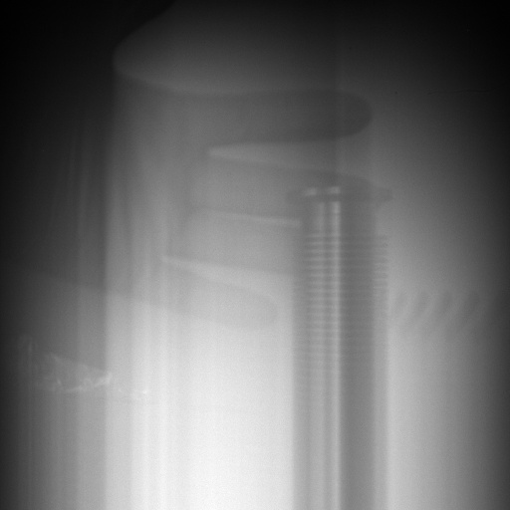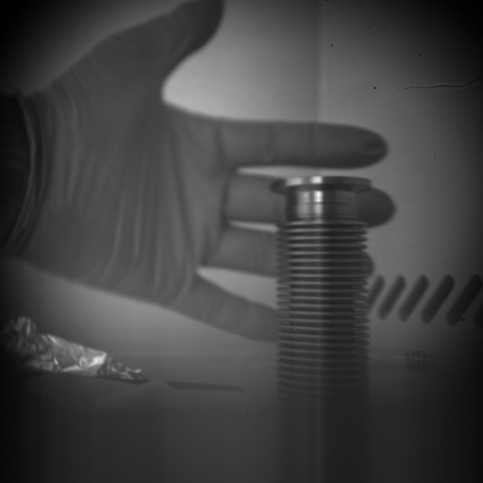
(a) (b)
Figure 6: (a) Image taken by the developed CCD software through an adjustable objective lens with low exposure. Streaking effects are apparent. (b) The second image has higher exposure time (0.5 secs). The objects in view are gloved-hand, a bellow, and used aluminum sheets.

Binning, Shift Speed, Image Area, Exposure
Horizontal and vertical binning is the process in which pixel counts are summed horizontally or vertically. A horizontal and vertical binning of n pixels will result in “superpixels” as shown in the figure below.

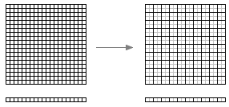
Figure 7: Binning is the hardware camera summing of pixel count values horizontally or vertically rather than software addition. This creates combined pixels called "Superpixels".

The speeds at which the count is shifted horizontally and vertically are the horizontal and vertical pixel shift speeds. The horizontal shift times available are: 1 µs, 2 µs, 16 µs, and 32 µs. Not all 512 by 512 pixels of image area is needed in all image acquisitions. The image area selection function allows the selection of the pixels needed by click and drag techniques.

Exposure is the length of time the acquisition and accumulation will stay active before the data is outputted. Minimum exposure time depends on horizontal and vertical shift speeds as well as image area selection.

Long Averaged Exposure

The hardware designed exposure function is problematic when long exposures are needed (eg. more than 10 seconds). The issue is that each CCD pixel has a maximum count of approximately 64,000 counts. Any more light on the pixel will damage the pixel permanently. However, SAXS experiments often demand long exposures to create higher contrast of images. The workaround to this issue is by employing software averaging of acquired values. Instead of acquiring values of total photons acquired, the rate at which the photon is hitting the detector surface is calculated instead.

Beamline Parameters Control

The control software for the camera also needs to be able to control and read the beamline parameters such as energy, slit size, etc.

AXis-readable File Export

AXis is a standard tool in data analysis for x-ray imaging used at the SM-beamline. The tool was developed in IDL by Adam Hitchcock. Input files for this software are in ‘xim’ and ‘hdr’ extensions. The xim (x-ray image) file is an ASCII text file of count data delimited by tabs. The hdr (header) file is the file defining all variables and parameters set during the acquisition of the particular xim image. This type of xim and hdr output support was implemented into the software.

Experimental Setup
Since having to disassemble internal components of STXM in order switch between a photomultiplier tube and the CCD was inconvenient, the CCD was initially placed outside the STXM chamber. It was later discovered that external placement of CCD is too far to pick up any scattering data and the camera was moved into the STXM chamber in order to shorten the distance between the sample and the detector.

External Setup of CCD
An opening flange was already available on the STXM end that is aligned with the beam propagation (z-) axis. An external mounting platform design was required. The platform needed to have two stages of linear translation: the x and the y axes. A Newport y-stage was available prior to designing the platform. The camera is to be placed on the y-stage with a bellow (figure below) connected to the opening flange from the STXM.

[bellow figure]

The camera is to be moved in the x-direction by two set screws placed horizontally pushing on either side of the camera. The Newport y-stage, however, requires a flat base to be mounted properly. By STXM geometry, the y-stage has to sit on the top of a large (radius) cylindrical flange. Adapters are designed to allow the y-stage to be mounted firmly and flat to the cylindrical flange top. The final SolidWorks design of this setup is shown below. The detailed schematic designs are listed in the Appendix.
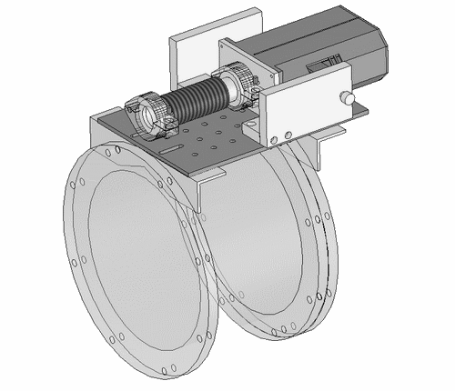

Internal Setup of CCD
The internal placement of the CCD involved placing the CCD on a 3-axis linear stage combination that was used for mounting of the photomultiplier tube. The photomultiplier tube was replaced with a different PMT. The replacement has a phosphorous layer at the tip of an optical fiber as shown in figure below. This PMT is used to minimize the area being blocked from the beam. Attached atop the camera, the PMT is angled downwards with the tip close enough to the sample in order to block the right amount. The placement of the PMT was done by trial and error.

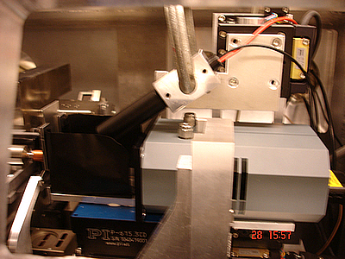
Figure 8 : Internal setup of the CCD and the PMT used for SAXS data acquisition. The PMT is held by a clamp attached to the arm of a linear stage. Note: except for the y-linear stage the PMT is attached to, both the CCD and the PMT share the same motion of x and z directional motion.

Beam Stop

The beam stop is required to block off the first order beam in order to properly analyze the scattering data. Though no image reconstruction is involved in this project, the 1st order is still blocked off by a beam stop in order to decrease the contrast between the bright and dim parts of the image. The beam stop is achieved by placing the phosphorous tip of the PMT. With this setup, the microscope is able to achieve both STXM and SAXS detection function.

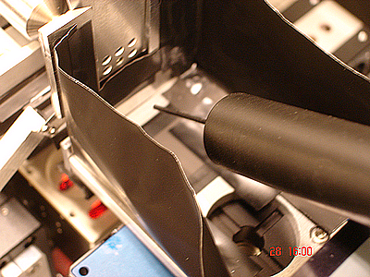
Figure 9 : PMT fine tip (approx 2.65 mm) blocking the 1st order beam divergent from the sample (bottom center hole of the 6 holes).

In the data sets (presented in the Appendix), the beam block is represented by the dark semi-circular shaped patch persistent in all sample scattering data images.

Discussion
Data acquisition was not completed as the camera failed after the camera was handled a couple of times. With rough diagnostics, it was determined that the failure source originated from the detector of the CCD rather than the electronics. Though not completed, a few images were recorded with the internal setup. This section will analyze the images and determine the meaning behind each image.

External Setup Data Acquisitions

Data

Analysis

Having to disassemble and reassemble internal components isn't very convenient so the first test run of x-ray imaging was done with the camera placed externally on the marked spot of Figure below. The camera was switched on in video sequencing mode at approximately 2 frames per second and the camera position was scanned by linear stages to search for signal.

Initially, no recognizable pattern was seen in view (figure a). However, a faint circle can be seen and that was placed into view by proper stage adjustment. This circle pattern didn't have strong enough of signal compared to the apparent noise and speck in the upper right corner. The origin of that particular speck could not be identified. The speck was present even when x-ray beam is shut off and all sources of light are disabled. When the camera is blocked with an object (a hand) the speck disappears. Since it was present in any position, it was simply ignored as noise. The circle pattern needed to be brightened and changing the beam energy seemed to improve the intensity. This change in energy changed the focus of the beam. This “donut-shaped” pattern was soon recognized as the zone plate (figure b and c). The edge of this zone plate is noted rough in figure b on the upper right corner. Initially this was assumed as a bad or burnt zone plate. However, with adjust ment of the OSA, the rough edge was removed simply because the OSA was in the way and distorted the edge (Figure c). Finally, the default sample of STXM was used to see if any interference pattern is present. The default sample is a test pattern of mesh structure shown below.

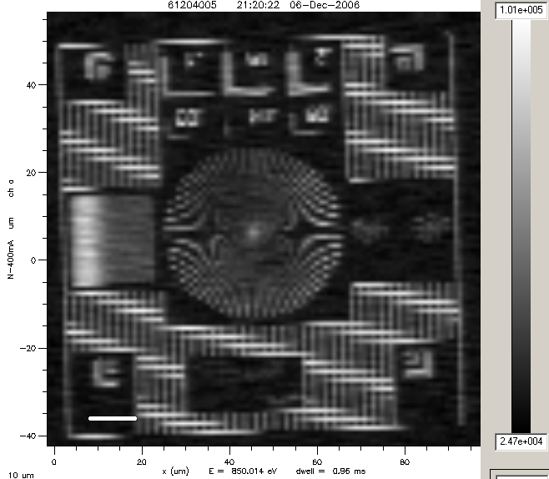
Figure 10: Test mesh pattern of silicon wafer used as initial sample. This image is constructed from the STXM method.

Figure d does not, however, show the speckled interference patterns of the x-ray scattering. It certainly may have been slightly distorted by interference, but the visible patterns are the result from method of transmission microscopy. The pattern represents an enlarged view of a corner of the mesh. No scattering pattern should be visible because the viewport of the camera is completely covered by the first order beam. The scattered beam has a lower intensity compared to the 1st order beam. In order to “see” the scattered pattern, the camera needs to have a larger viewing angle and detect beyond the zone plate width as shown in figure below.

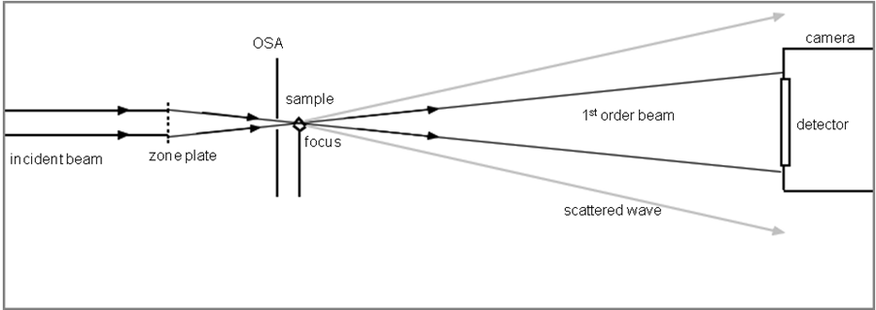
Figure 11: Ray geometry showing that the CCD detector is placed too far from the sample in order to detect any scattered waves or speckles.

Proper SAXS experimentation typically uses a beam stop to block off the first order beam in order to properly analyze the scattered image. The data obtained in this first acquisition clearly indicates that the camera is too far away from the sample because the first order beam that needs to be blocked off is covering the entire detector surface. This was the hint to change camera position and place it inside the STXM chamber.

Internal Setup Data Acquisitions

Data
More than 20 images were taken when the CCD was placed inside the STXM chamber. For formatting reasons, the images are in the Appendix section. Only the few that have noticeable characteristics for analysis are shown here.

Analysis

More data were taken for the case of internal setup. Due to complication with camera failure, only a few variables were studied. These variables include:
- change in focus
- change in energy
- change in slit size
- consistency

Change in Focus

SAXS Simulation
The CCD camera broke after internal setup data acquisition. Manual diagnostics showed that the source of failure is in the detector chip rather than the electronics. Due to this, the project change to a different approach in order to understand small angle x-ray scattering. The latter part of the tasks was to design a simulation algorithm. This simulation used spherical particle approximation and this section of the report discusses the theory and simple particle simulation data results.

Debye's Formula – Spherical Particle Simulation

Small angle x-ray scattering has previously been simulated using pre-pentium machines (Pantos, et al. 1996). The simulations were achieved through simple modelling of sample structures. As previously mentioned, the amplitude of the interference pattern formed by small angle x-ray scattering of a particular sample is the Fourier transform of the sample's electron energy distribution function (Kratky and Glatter 1982). This amplitude is defined as:
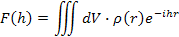
Where h is the scattering vector and r is the vector directed from the origin of a sample. With the amplitude, the intensity is then described by multiplying the amplitude with its complex conjugate:
For simple shapes (sphere, cylinder, cones, cubes, etc) the fast Fourier transform (FFT) is quick and easy to calculate by computational means. Random ordered and shaped objects, however, require a workaround to properly determine the transforms. The simplest method to model any shape object is the spherical particle model. This model assumes the sample is composed of an array of small spherical particle scatterers. The scattering is determined from each particle and then summed accordingly. The intensity of spherical scattering is derived by Lord Rayleigh (Kratky and Glatter 1982) as:

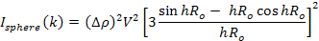

Particle scattering requires an averaging to properly apply to non-symmetric or mobile particles such as fluids. With this condition, Debye introduces a second term to the intensities which describes the intensity distribution about an axis of revolution between any two particles (Guinier and Fournet 1955). This term is described by the expression:
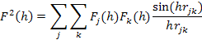

Where and are form factors of the j^{th} and k^{th} particle in the system. is the distance between the j^{th} and k^{th} particle. Since a pair of j^{th} and k^{th} particle also can be described reversibly by k^{th} and j^{th} particle. The final intensity as derived by Debye is thus:

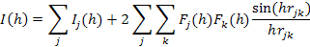

In terms of simulation, this equation can be further simplified to reduce processing time. As Pantos et al. used, the assumption of identical particles can reduce the and to just . Since the square of the form factor is the intensity, the above equation is simplified to:

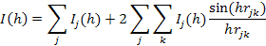

Further simplification factors the individual particle intensity I_{j}(h) term:

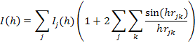

The simulation performed by Pantos simplifies the Debye approximation even further by reducing the function using a particle-pair histogram. This simplification was omitted since the change doesn’t seem to affect processing time with today’s CPU compared to the ones used more than a decade ago. The simulation was performed by using GNUPlot script. A double particle GNUPlot script is attached in the Appendix.

Single Particle Scattering Simulation
Sample data simulated from using single particle equation.
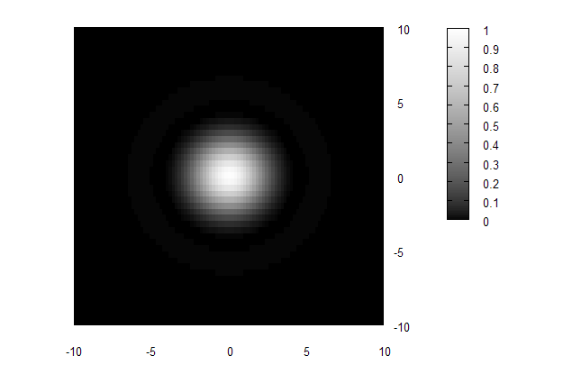
Figure 12 : Single particle simulation with arbitrary electron density and unit radius. A faint ring is seen around the central maximum, the ring shows the second maximum from the sinc function.

The reliability of the simulation cannot be determined from this simulation. The horizontal intensity profile of this simulation matches the given graphs from Glatter and Kratky. The profile graph, as predicted from Rayleigh’s intensity definition, resembles a squared sinc function shown below.

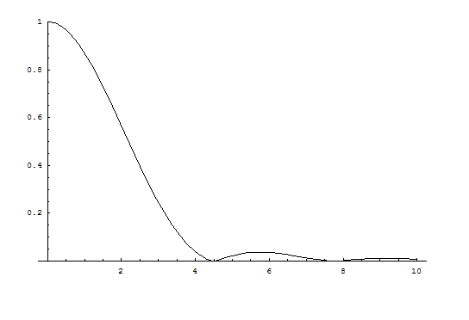
Figure 13 : Mathematica output of the intensity function defined by Rayleigh.

Paired Particles Scattering Simulation
Sample data simulated from a two horizontal adjacent particle system.
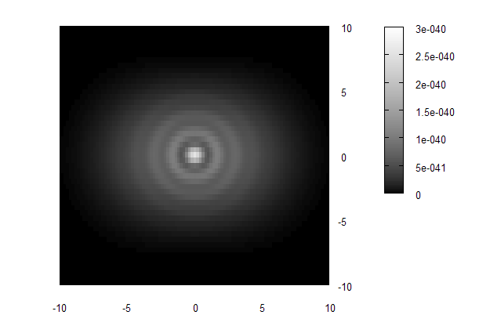
Figure 14 : Double particle scattering simulation data. The two particles are placed adjacent to each other horizontally. This likely is not the correct simulation.

Initially, this simulation seems valid. The slight interference pattern difference compared to the single particle seems to show a proper scattering. However, when the positions of the particles were shifted to offset from the x-axis, the interference pattern is not an offset from the data above.

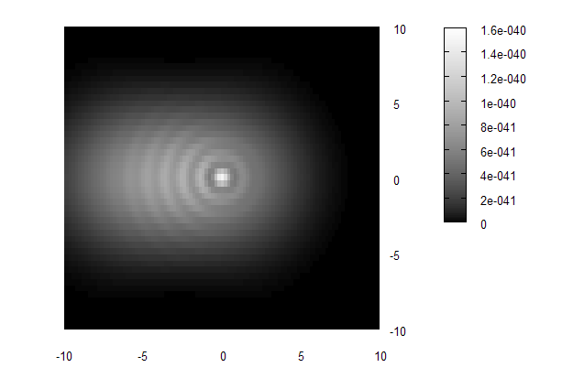
Figure 15 : Simulation showing fault. With collimated propagating beams, the intereference pattern should show identical intereference between this and the interference above in

Though the setup in STXM for SAXS simulation used focused beam from a zone-plate, the DeBye approximation dealt with collimated beam.

Conclusion
Although the camera failure lost SAXS experimental time, a few concepts of SAXS can be established from the available results. A few variables were tested on the iron particle solution sample. Focusing and defocusing changed the grain size of the interference pattern due to the focus from lower electron density zones to higher electron density areas. With higher electron density, the amount of scattering increases and produces more interference patterns. Different energy scans showed no apparent relation since the images acquired produced random scattering. However, the contrast between scattering patterns detected at smaller radius than at higher radius was slight larger at lower energy. Lastly, a change in slit size parameter showed a change in scattering intensity histogram. With more input beam, the intensity maximum is increased to higher count rates. There is nothing unusual about this result since a larger slit size allows more beam to pass producing a higher count rate image.

References
Azaroff, L.V., R. Kaplow, N. Kato, R.J. Weiss, A.J.C. Wilson, and R.A. Young. X-Ray Diffraction. McGraw-Hill, 1974.

Beetz, T. Soft X-ray Diffraction imaging with and without lenses and Radiation damage studies. PhD Thesis, New York: Stony Brook University, 2004.

Duffieux, P.M. The Fourier Transform and Its Applications to Optics. New York: John Wiley & Sons, 1983.

Ersoy, O.K. Diffraction, Fourier Optics and Imaging. Hoboken: John Wiley & Sons, 2007.

Guinier, A., and G. Fournet. Small-Angle Scattering of X-rays. New York: John Wiley & Sons, Inc., 1955.

Kratky, O., and O. Glatter. Small Angle X-ray Scattering. London: Academic Press, 1982.

Pantos, E., and J. Bordas. "Supercomputer simulation of small angle X-ray scattering, electron micrographs and X-ray diffraction patterns of macromolecular structures." Pure & Applied Chemistry Vol. 66, 1994: 77~82.

Pantos, E., H. Garderen, P. Hilbers, T. Beelen, and R. Santen. "Simulation of small-angle scattering from large assemblies of multi-type scatterer particles." Journal of Molecular Structure, 1996: 303-308.

Suhonen, H. Simulation of Small-Angle X-Ray Scattering from Collagen Fibrils. Master's Thesis, University of Helsinki.

Appendix
Magnetite: Sample Datasheet

Manufacturer’s Name: Ferrotec (USA) Corporation

Components:

The precise composition of this mixture is proprietary information. A more complete disclosure will be provided to a physician or nurse in the event of a medical emergency.

Magnetite: 1 – 4% by volume
Water Soluble Dispersant: 7 – 27% by volume
Water: 69 – 92% by volume

Boiling Point (F): 212
Specific Gravity 1.13 to 1.26
Vapor Pressure (mm Hg.): 17.5 @ 20 C
Percent Volatile by Volume 83-96 by volume
Vapor Density (AIR = 1): <1
Solubility in Water: Complete
Appearance & Odor: Black Fluid, mild soap-like odor

GnuPlot Simulation Code

# Title: Small Angle X-Ray Scattering Simulation
# Filename: SAXS_2.gnu
# Author: Tso (Peter) Chen
# Date: July 26th, 2007
#

#Declare Variables
R = 0.5
Window = 10
Rho = 2E-20

# Declare Constants
Pi = 3.14159265
V = (4/3)*Pi*R**3

# Graph Aesthetics
#set nosurface
#set pm3d at b
set autoscale z
set palette gray
set yrange [-Window:Window]
set xrange [-Window:Window]
set ticslevel 0
set isosample 50
set size square

# Set viewing angle from top view
set view 0,0

# Declare Hypothenuse Vector
i(x,y) = sqrt(x**2+y**2)
h(x,y) = R*i(x,y)

# Declare Offset Particle
a(x) = x
u(x) = x + 4*(R*2)
v(y) = y

# Define Form Factor Functions
F(x,y) = Rho * V * (3*(sin(h(x,y))-h(x,y)*cos(h(x,y)))/(h(x,y)**3))

# The Distance Calculation Function
Dist(x1,y1,x2,y2) = i(x1-x2, y1-y2)

# Define the Correlation Function

# Define the function for single particles
i_single(x,y) = Rho**2 * V**2 * (3*(sin(h(x,y))-h(x,y)*cos(h(x,y)))/(h(x,y)**3))**(2)

# Define the function for Total Intensity

I(x,y) = i_single(a(x),y) + i_single(u(x),v(y)) + 2*(F(a(x),y) * F(u(x),v(y))) * sin(i(x,y)*Dist(a(x),y,u(x),v(y)))/(i(x,y)*Dist(a(x),y,u(x),v(y)))

# Plot it.
splot I(x,y) title "SAXS Simulation" with pm3d

GnuPlot-Script-Generating HTML/Javascript

<html>
<head>
<title>Peter's Awesome GNUplot Correlation Summation Script Generator</title>
</head>
<body>

<script>
var List = new Array(0);
var xList = new Array(0);
var yList = new Array(0);
var myArray = new Array(0);
var completeString;

// Check the validity of the input coordinates.

function checkValidity(){
//Reset Values for
xList.length = 0;
yList.length = 0;
List.length = 0;
myArray.length = 0;
completeString = "";
myString = "";

myArray = document.getElementById('inputControl').value.split("\n");

for( i = 0 ; i < myArray.length ; i++ ){
if (myArray[i].indexOf(',') == -1) {
return;
}
if (myArray[i].split(',').length > 2) {
return;
}
}
Process();
}

function Process(){
for ( i = 0 ; i < myArray.length ; i++ ){
xList.push("(" + myArray[i].split(',')[0].toString() + "*R*2)");
yList.push("(" + myArray[i].split(',')[1].toString() + "*R*2)");
}

for ( i = 1 ; i < myArray.length + 1 ; i++ ){
for ( j = i + 1 ; j < myArray.length + 1 ; j++ ){
if (i == j) {break}
var myString = "";
myString += "Corr_" + i.toString() + "to" + j.toString() + "(x,y)";
List.push(myString.toString());
myString += " = sin(i(x,y)" ;
myString += "*Dist(x+";
myString += xList[i-1].toString() + ",y+" + yList[i-1].toString() + ",x+";
myString += xList[j-1].toString() + ",y+" + yList[i-1].toString() + "))/";
myString += "(i(x,y)*Dist(x+";
myString += xList[i-1].toString() + ",y+" + yList[i-1].toString() + ",x+";
myString += xList[j-1].toString() + ",y+" + yList[i-1].toString() + "))";

//alert(myString);
completeString += myString + "\n<br><br>";
}
}

completeString += "\n<br><br>";

// --- Create a CorrelationSum(x,y) function
myString = "";
myString += "CorrelationSum(x,y) = ";
for (i=0 ; i < List.length; i++) {
myString += List[i].toString() + " ";
if(i+1 == List.length) {break}
myString += " + ";
}
completeString += myString + "\n<br><br>";

// --- Create a I(x,y) function
myString = "";
myString += "I(x,y) = i_single(x,y) * (";
myString += xList.length;
myString += " + 2 * (";
myString += "CorrelationSum(x,y)))";
completeString += myString + "\n<br><br>";

document.getElementById('outbox').innerHTML = completeString;
myString = "";
}

function clearBox(){
document.getElementById('inputControl').value = "";
}

function clearCode(){
document.getElementById('outbox').innerHTML = "(Script not yet generated)";
}

function ClipBoard(){
Copied = outbox.createTextRange();
Copied.execCommand("Copy");
}

</script>

<style type="text/css">
a{
text-decoration: none;
}

a:hover{
text-decoration: underline;
}

body {
font-family: verdana;
font-size: 11px;
}

#inputControl{
width: 300px;
height: 200px;
text-align: center;
}

#coordBox{
text-align: center;
width: 400px;
}

#outbox{
padding-top: 20px;
padding-bottom: 20px;
width: 800px;
border: dotted 1px gray;
font-family: Courier New;
font-size: 11px;
text-align: left;
padding: 20px;
overflow: auto;
}

</style>

<br>
<br>
<br>
<center>

<br>
<br>
<div style='width: 840px; text-align: right;'>
<a href="javascript:ClipBoard()">[Copy script to clipboard]</a>
<a href="javascript:clearCode();">[Clear]</a>
</div>
<br>
<br>
<div id='outbox'>
(Script not yet generated)
</div>

<div id='coordBox'>
<br>
Coordinate Input:
<br>
<br>
<textarea id='inputControl'>
</textarea>
<br>
<br>
<input type='button' value='Generate' onClick='checkValidity()'>
<input type='button' value='Clear' onClick='clearBox()'>
<br>
<br>
</div>

<br><br><br><br>

</center>

</body>
</html>
Internal Setup Acquired Images/Data

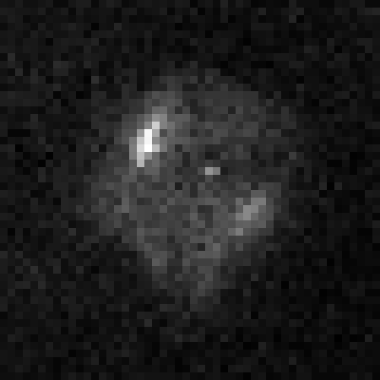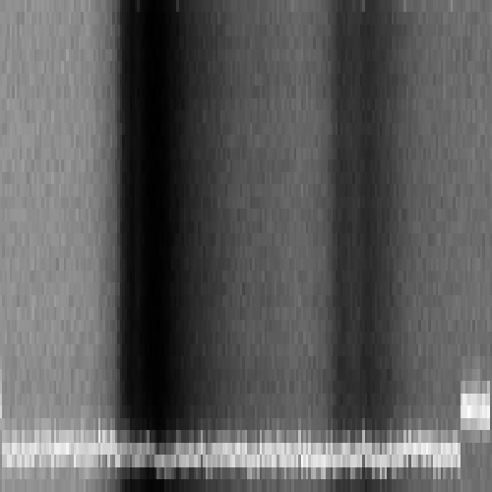

70628015_a.bmp 70628018_a.bmp

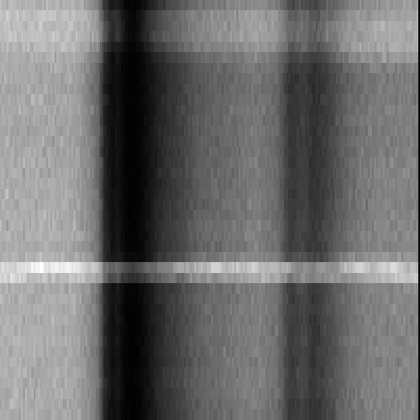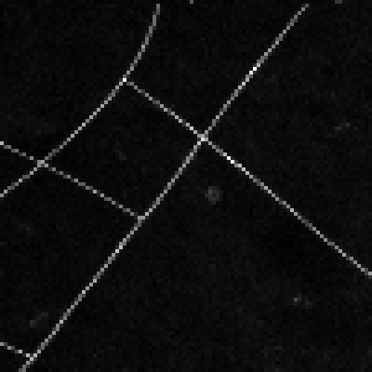

70628019_a.bmp 70628020_a.bmp

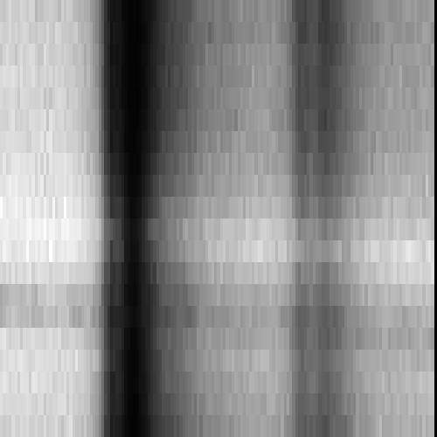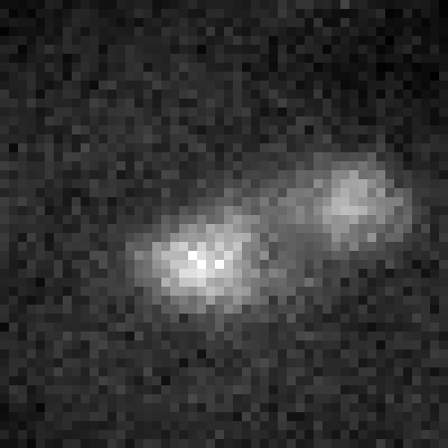

70628021_a.bmp 70628023_a.bmp

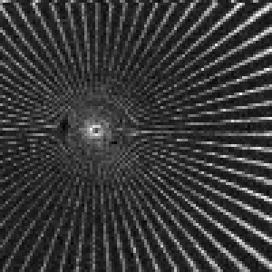
CCD Camera External Setup Solidworks Sketch

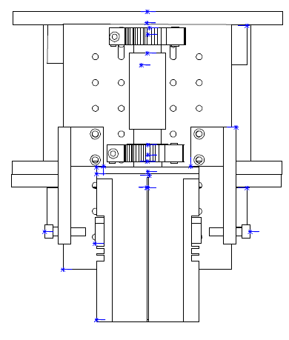

Image adapted from (Beetz 2004)

