

June 2006
Volume 1, Issue 2

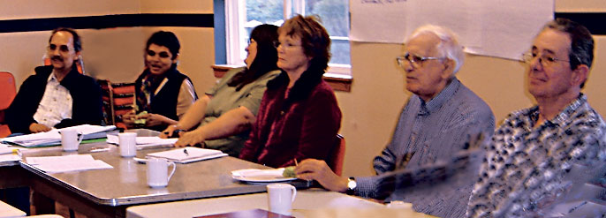
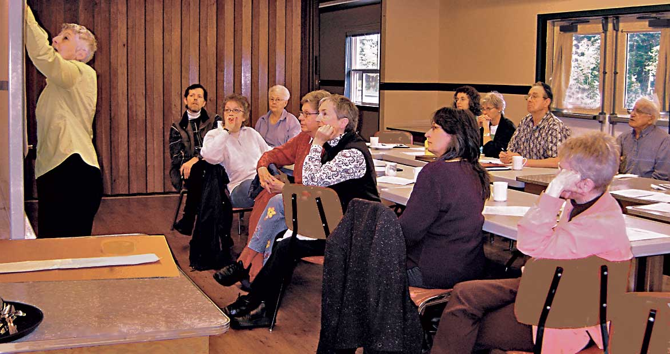
In this issue

We revisited and clarified our vision and goals, established priorities for the upcoming year and developed action plans to implement our list of priorities.

It’s been more than a year since our last newsletter, but what a year of accomplishments!
The latest being a Strategic Planning Session at Providence Farm in the Cowichan Valley. Seventeen guests and members of our board and Core Team met for the day under the
skilled guidance of Facilitator, Heather Payne.

Welcome to the second edition of the BCCHP newsletter. In this issue we update you on the activities of the Coalition and feature articles by our members and supporters.
Highlights include:

The year in review
Beyond the Band-Aid - a publication on community organizations and the determinants of health
Anne Zinkgraef’s internship with us
Two articles that encourage us to think beyond programs and services; another that questions our use of the term, “developing community capacity”
One step I can take to promote health
Interior Health’s initiative, Community Action for Health
Introduction to BC Healthy Communities
Community Inspired Health Promotion - What is it?
Coalition to host the International Network of Health Promotion Foundations
What are the benefits of Health Promotion Foundations?
“Did you know?” Stats on voluntary, non-profit sector contributions to society

2005-06: the Year in Review
Contributed by Irene Dutton, BCCHP Core Planning Team

2005 was another busy year for Ronnie and her band of trusty cohorts. I'll try to categorize
activities for your review.

The Organization

A membership structure has been developed and approved by the Board. Peter Kiessling is looking after membership applications.
The Coalition held its second Annual General Meeting in Duncan on June 28/06.
Secure funding for ongoing operations of BCCHP is a continuing challenge. To this end meetings have been held with potential funders, with results best described as lukewarm.

Meetings/Forums Hosted

May 2005 - Advocacy for Health forum held in Vancouver with 84 attendees. Guest speakers were Daisy Anderson, Christine Gordon, Francisco Ibanez-Carrasco, and Dr. Brian Emerson who addressed changes in the BC Health Act.
November 2005 - Community Conversation, sponsored in collaboration with Imagine Canada. A coming together of 43 Cowichan Valley volunteers/ non-profit organizations to provide input on a national campaign to increase voluntary sector awareness.
April 2006 – BCCHP Strategic Planning session in Duncan. It promises to be a busy and exciting year!

Papers and Projects

A Consultation Paper, Funding Health Promotion: from Challenges to Opportunities, has been produced and circulated. It proposes to engage funders and community organizations in a dialogue to promote better understanding of funding issues, explore possibilities, and develop collaborative solutions for change.
January 29, 2006 – production of Beyond the Band Aid: Health Promotion – Creating Healthy Communities from the Grassroots Up. Email ronnieph@shaw.ca if you’d like a copy.
Anne Zinkgraef from Berlin was in the Cowichan Valley for a 4-week internship with BCCHP.
The BCCHP is part of an international team headed by the Centre of Excellence for Women’s Health in Vancouver developing a research proposal that focuses on lone motherhood, social experience and chronic disease.
Completion of initial research for a province-wide Community Learning and Mentorship Network. Our thanks to the Vancouver Foundation’s BC Medical Services Foundation for funding this research component.
A one-year research and community development project is underway between the BCCHP, Fraser Health, Chilliwack Health Services and community partners: the Mayor’s Committees on health and social issues, and the Chilliwack Social Planning and Research Council. One aspect of this initiative is to facilitate a forum - Action for a Healthy Community: Collaborate, Resource and Empower.

Submissions - The BCCHP provided input from our perspective into:

Revision of the BC Health Act
Draft Bangkok Charter
Draft Vancouver Island Health Authority 5-year plan

All in all a busy and productive time, with lots of stepping stones to an equally busy 2006.

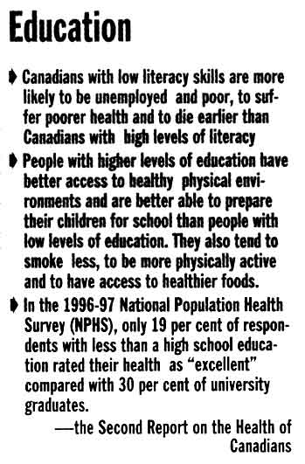
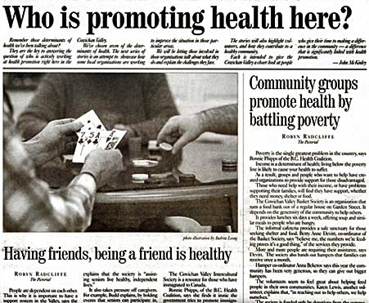
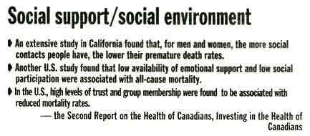
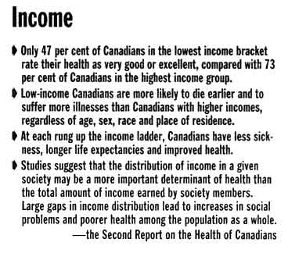
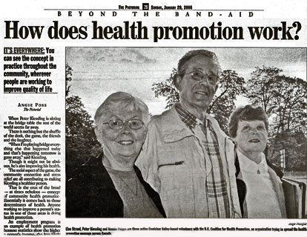
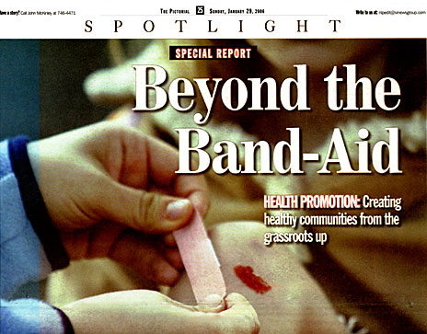
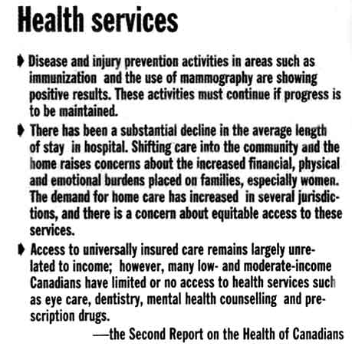
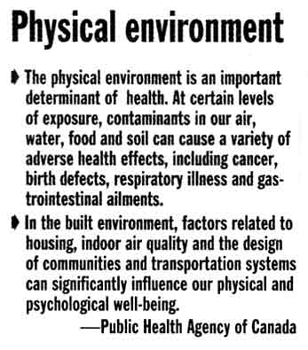
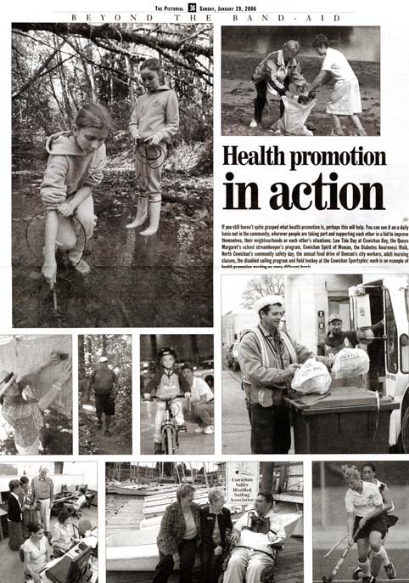

BCCHP DEMONSTRATION PROJECT: A 16-page special edition of the Pictorial newspaper January 29th, 2006 outlined the contributions of Cowichan Valley nonprofit societies to health promotion.

Beyond Services

My friend was dying. Her blue eyes sparkled with determination as she extended her hand across the table to clasp mine in a surprisingly strong grip. With the wisdom of an 82-year old mentor she gently shared, “It’s the relationships in life that count, my dear. It’s the relationships.”

We can’t pick up a health-related article, report or newspaper these days without reading about services. Service plans, service delivery, service demands, integrated services, seamless services, primary health care services, prevention services, population and family health
services….

One has to ask, “Are more services the answer to the myriad of health challenges faced by communities today?” Or are they slowly overtaking the role of human connections, peer supports, informal networks, community wisdom, self determination and personhood? Are we becoming slaves to the very systems that are supposed to promote our health and wellbeing?

John McKnight cautions against the iatrogenic effect of human service tools noting they can be costly and disempowering. Services tend to focus on deficiencies and needs, on problem solving by experts and systems. Unless checked, a forest of services emerges to create an artificial environment in which the “power of professions and service systems ascend while the legitimacy, authority and capacity of citizens and community descend” (McKnight, 1999, Do No Harm: a Policymaker’s Guide to Evaluating Human Services and their Alternatives”).

Before embarking on more services, we might pause to consider the wisdom of my friend, “It’s the relationships in life that count ….”

Health promotion

gives people power to identify their issues and come up with solutions.

provides long term solutions to society's health concerns.

permits people to challenge and reduce inequalities in their lives.

addresses the determinants of health through cooperation and community participation.

provides resources that people can control, not services that are controlled by those supplying them.

(http://www.vcn.bc.ca/bchpc/whatsHP.html)

Resources

Ottawa Charter for Health Promotion (1986)
http://www.phac-aspc.gc.ca/ph-sp/phdd/docs/charter/

Jakarta Declaration (1997)
http://www.vcn.bc.ca/bchpc/PDF/Jakarta%20Declaration.pdf
Bangkok Charter for Health Promotion (2005)
http://www.who.int/healthpromotion/conferences/6gchp/bangkok_charter/en/print.html

“The price we pay for creativity and free will is an inability to foresee and intend future outcomes.”

Ralph Stacey, 1996, Emerging Strategies for a
Chaotic Environment Long Range Planning, Vol. 29.

Beyond Programs:
A Parable

fun, to enjoy life and have friends. I want the same opportunities as all of you; I want to be happy.”

And there was a long silence. And lo, everyone realized that they must look beyond their programs.

But they were troubled, and they asked: Would not each person need their own unique supportive environment and their own individual measure of its quality?”

And the prophet replied: “Even as you say, so should it be done. Just as you do for yourselves.”
Adapted from an article by Michael McCarthy
Transition Magazine, February 1993

For myself:
Go for a walk.
Take an exercise class.
Buy local fruit and vegetables.
Drink more water.
Read a good book.
Balance my time between family, friends, play, work and sleep.

For my community:
Get to know my neighbors.
Volunteer my time for a local cause.

What will you do today to improve your own
personal health and to promote a healthier community?

In the beginning, there was placement, and lo, we were happy when it happened, as placement was not mandated for adults who happened to experience severe disabilities.

And so, we said, this is good. And placements multiplied and filled the earth.

And then, we said, let us make programs, which focus on serving clients. And clients were defined and labeled, and grouped according to their labels and assigned to programs based on their labels.

And programs created services for each label, and agencies developed unit costs for each service.

And programs prospered and multiplied, and we said, this is very good.

And as programs multiplied, a cry arose: Let us evaluate these programs to see how good they really are.

And performance indicators, best practices, outputs, profitability, quality assurance, compliance plans, diversification, results management and other program measures were created. And they multiplied and filled volumes.

And in those times, a person arose who was a client, but who was also a prophet, and said: “I don’t want to be a client; I want to be a person. I don’t want a label; I want a name. I don’t want services, I want support and help. I don’t want a residential placement; I want a home. I don’t want a day program; I want to do meaningful and productive things. I don’t want to be ‘programmed’ all my life; I want to learn to do things I like, and go places which I like. I want to have

One step I can take
to promote health

Anne’s Internship

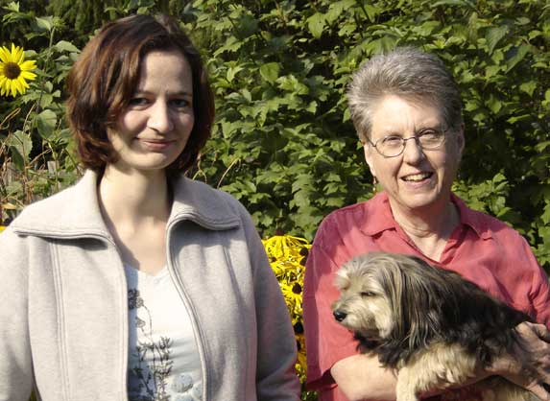
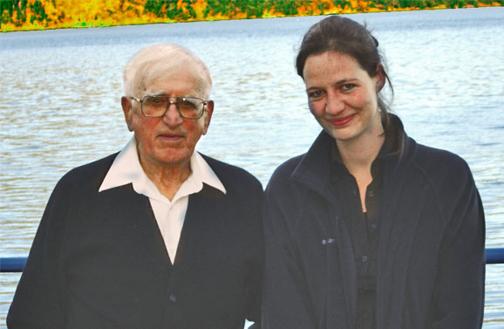
In September 2005, Anne Zinkgraef, post graduate student of Public Health at the Free University in Berlin, Germany, spent a one-month internship with the BCCHP. What follows is Anne’s account of that experience.

I first got to know the BC Coalition for Health
Promotion through a commentary paper on the Bangkok Charter, handed out to us by a professor at university in Berlin last spring. Doing some research I found out about the goals, the concept (framework) and projects of this organization that left me wanting to know more. After a first contact, followed by some very friendly emails, I had a placement as an intern and was facilitated with an accommodation for a time-period of four weeks.

This might seem like quite a short while to do an internship, but it was so intense, so full of information and impressions, and yet so different from all the internships I had done so far (and I have done quite a few of them), that it was all the way worthwhile.

Besides joining some interesting meetings and discussions and participating in the day-to-day activities on different projects, like for instance the special media project on the role of voluntary, nonprofit organizations in health promotion, my main responsibility was an internet research, analyzing data for the Community Learning and Mentorship Network project. Not only did I learn to fill some of the rather frequently to inflationarily used keywords of health promotion with more meaning and sense, but I had the pleasure and honour to get to know a true grass-roots organization and its interesting and dedicated members.

Walking the talk on health promotion is one thing that is definitely more than needed in our times, and this organization does a lot of walking and talking for health promotion to keep this work going and fit some more puzzle pieces into the big
picture’.

This work to perform (voluntarily) on a daily basis can be frustrating and hard at times, because a good part of it is to write funding proposals and to convince people of ideas and strategies for
projects to get some financing to put the plans into action. Therefore I admire these peoples’ courage, their strength and endurance, their way of positive thinking and living up to their ideals. I left
Vancouver Island and the beautiful Cowichan Valley hoping to take some of that spirit with me, and, after the hospitability and warm-hearted friendliness I experienced, knowing that I had made some new friends.

Interior Health
Promotes Community Action for Health

The Interior Health Authority has provided $200,000 for 51 grants up to $5,000 each to help communities make local policy or environmental changes that promote health and prevent illness.

An additional $1,000,000 will be made available to support health promotion programs that address the provincial ActNow BC targets of healthy eating, active living and obesity reduction. Seven host agencies, representing the seven areas in the Interior Health region, will oversee the allocation of
$425,000 in grant funds. An additional $270,000 will be provided to hire a half-time Community Developer for each area.

Community Action for Health is the first of its kind in the province and involves local communities in creating environmental and policy changes that will be funded to support the provincial ActNow BC targets. For more information contact Rose Soneff, Leader – Community Development and Population Health, Interior Health Authority: rosario.soneff@interiorhealth.ca.

BC Healthy Communities (BCHC)

BC Healthy Communities is officially open for business. Vancouver Island facilitator, Kerri Klein gave an update of their progress at the BCCHP Annual General Meeting on June 28th. To learn about the BCHC, check out their website at: www.bchealthycommunities.ca.

Fall plans include:

- A community conversation kit designed to spark dialogue and encourage people to talk about health in our communities
- A capacity-building guide to support communities in putting the healthy communities framework into action
- A regional forum
- Distribution of 100 seed grants of $2500 each

You can contact BCHC via email at: bchc@civicnet.bc.ca or phone: 250-356-0892

Community-Inspired Health Promotion - What Is It?

Community-inspired health promotion refers to planned actions, generated by the grassroots, in which people are empowered to have greater control over the advancement of their own physical, mental, spiritual and social wellbeing. This approach acknowledges that citizens know best the strengths and challenges of their own communities.

Community-inspired health promotion is most empowering when solutions are effectively supported through funding, information, learning opportunities, and technical assistance.
BCCHP to host
International Network of Health Promotion Foundations (INHPF)

In June 2007 the BCCHP will host the 7th annual meeting of the INHPF. It is the first time an Associate member has had this unique opportunity.

The Coalition was granted Associate membership in April 2004, after attending a Network meeting in Budapest, Hungary.

To date, there are six full and six Associate members in the INHPF:
www.hp-foundations.net/index.php.

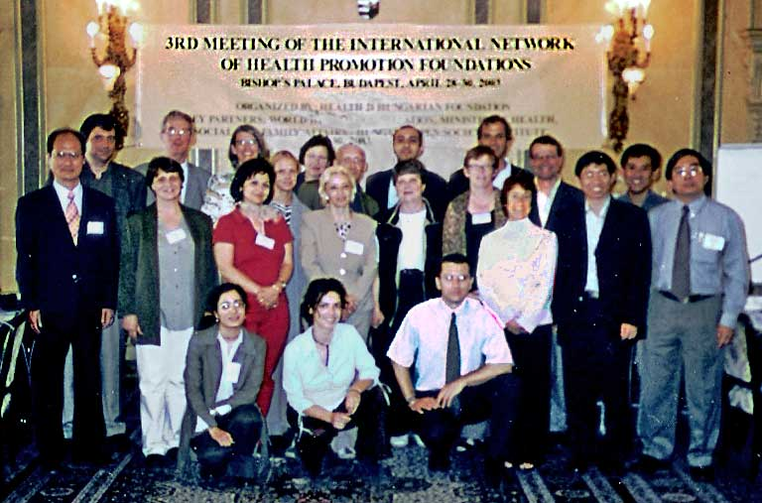
Meetings of the Network provide a chance to exchange information and benefit from the experiences of other countries in establishing and maintaining health promotion foundations. In conjunction with our role as host in 2007, the BCCHP will send a representative to the INHPF’s annual meeting in Montreux, Switzerland this November.

provide a comprehensive, coordinated, focused approach to health promotion
promote flexibility, responsiveness and innovation
address inequities and promote health by working with and across many sectors and levels of society
build a health promotion evidence base
have the ability to promote community involvement, thus reducing acute care interventions, relieving pressure on health authorities and lowering overall health costs
reduce bureaucracy and administrative costs
work with government but not as government

provide opportunities to leverage funds from other sources
exercise a high level of autonomous decision making and are not aligned with any one political group
offer permanence and stability despite changes in governments
increase opportunities to learn from other Health Promotion Foundations and share knowledge, experiences and tools with them
are transparent and accountable

For more information see the BCCHP Position Statement on Financing Health Promotion in BC:
www.vcn.bc.ca/bchpc/DOC/posFinance.doc.

What are the benefits of
health promotion foundations?

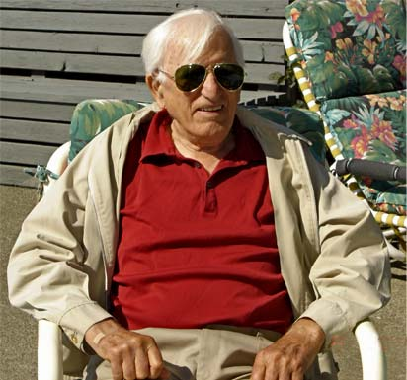

Garth Harvey brings a quick wit and down-to-earth presence to the Coalition’s Board of Directors and the Core Planning Team. He is a founding member of the BCCHP, President of the Cowichan Family Caregivers Support Society and recipient of the national 2006 Caring Canadian Award.
I have been asked to write a few words about what I think about Community. There is an expression: the more things change the more they stay the same. For over 80 years I have been experiencing Community and I think this expression is accurate. Let me explain. Two scenarios.

It is springtime on the prairies, the time to mend fences, till soil, plant seed, clean buildings: all the things to ensure one’s existence for another year. A newly-married couple arrives at their farm and disaster strikes. A broken leg. I do not know how the word was spread, but on the following weekend men from miles around showed up with their tools and knowledge. The women came with their gifts to work and to organize. The spring work is finished from cleaning the chicken house to mending the fences. Sunday evening. And it cannot get much better than that!

It is said that good fences make good neighbours, which is just another way of saying, “I will respect and protect my neighbour’s space.”

Fast forward 60 - 65 years to the early years of a new century in one of the richest provinces in one of the richest countries in the world. Now there is social assistance, welfare, pensions, even Medicare. Just like heaven.

I am listening to a lady tell of her experiences with “heaven”. She looks tired but well content within herself, although her husband had recently died after suffering for years with Alzheimer’s disease. In spite of great pressure from the experts, with the help of the Community, she had kept her husband with her ‘until death do us part’. Joe had died in His house, in His bed, in the home his wife had kept for him. And it does not get much better than that!

Two events years and miles apart, but the things that matter were the same. A Community looking after its Own, with its Own know-how, its Own compassion and its Own resources. And it does not get much better than that!

Develop community capacity? May the saints preserve us! Just give us a few resources and room to grow. And who can imagine what could be better than that!

Officialdom to Develop
Community Capacity

There are approximately 20,000 nonprofit and voluntary organizations in BC. 56% of these are registered charities.

Collectively, these organizations have total annual revenues of $11 billion and a total paid staff of 147,000.

1.5 million people contribute 114 million hours of volunteer time annually to organizations in BC. This is the equivalent of approximately 60,000 full-time jobs.

60% of organizations have no paid staff and are completely run by volunteers.

Voluntary and nonprofit organizations touch
virtually every aspect of Canadians’ lives.
These agencies have a significant presence in BC communities and are responsible for
addressing many of those factors that determine the health and quality of life of citizens.

But sustainable funding for community-inspired initiatives continues to elude us. According to Katherine Scott (2003): “The instability of the
sector is threatening the future of a diverse range of social, health, cultural, recreational,
environmental, and other not-for-profit
community services for millions of Canadians”.

References
Scott, Katherine. 2003. Funding matters: The Impact of Canada’s New Funding Regime on Nonprofit and Voluntary Organizations. Canadian Council on Social development, Ottawa, Ont.
Canadian Centre for Philanthropy. 2003. The nonprofit and voluntary sector in British Columbia, Toronto, Ont.
Canadian Centre for Philanthropy and the Coalition of National Voluntary Organizations. 2000. Volunteering in British Columbia. National Survey of Giving, Volunteering and Participating.

For more information on Canada’s charitable and nonprofit sector see the June 2006 Voluntary Gateway reports released by Imagine Canada: http://voluntarygateway.ca. Reports include a profile of the sector in BC and key recommendations for government, businesses and organizations across Canada.

Else Strand, Chair
Irene Dutton
Garth Harvey
Margaret Hess
Peter Kiessling
Gillian Leverkus
BC Coalition for
Health Promotion
Tel: 250-746-1797
Fax: 250-746-0700
Email: ronnieph@shaw.ca
Web: www.vcn.bc.ca/bchpc/

Design: Christopher Armstrong
Email: christopher@inno-vision.ca

June 2006
Volume 1, Issue 2

Did you know?

BCCHP 2006
Board of Directors

"Our lives begin to end the day we become silent about things that matter."
Dr. Martin Luther King Jr.

